A WALKING CHALLENGE: Inter-form OR Inter-year group competition
Healthy competition is a great way to generate enthusiasm about a campaign. You could even get the teachers involved competing against each other or start a ‘beat the teacher’ initiative! For students who live further away and travel by bus or car, you could encourage them to ‘Drop a Stop’ or ‘Park and Stride’ so they at least walk for part of their journey.

AIM:
- Increase the numbers of students walking for some or part of the journey to school.
- Reduce congestion around the school gates.

TOP TIPS FOR ORGANISING YOUR COMPETITION:

- Students use smartphone App to record their steps. We recommend ‘Pacer Pedometer & Weight Loss Coach’ compatible with Android and iOS. The App can run in the background so it is not necessary to have your phone in your hand for it to work.
- Following your assembly, recruit 10 volunteers from each form group to take part.
- YTAs visit form groups on Monday of Active Travel Week to register the participants and again on Friday to record the step totals from each participant’s phone.
- The winner is the group with the most steps. You could set a specific target, for example, the class to collectively walk the distance of London to Brighton (60 miles) is the winner!
- As a prize you could offer Sports Vouchers to further incentivise an active lifestyle. There is a maximum of £250 funding available for your YTA project.

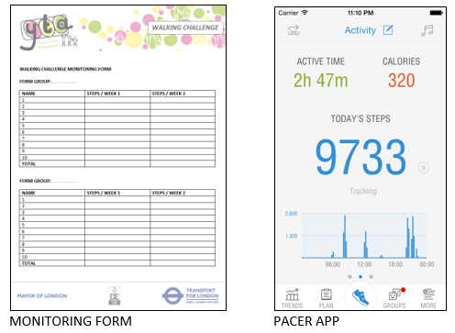

CREATE AN ACTIVE TRAVEL ZONE
An Active Travel Zone is a designated area around your school in which students are encouraged to walk or cycle instead of travelling by bus or by car. You will need to design your own map of the area showing safe walking routes into school. For students who live further away, you could encourage them to ‘Drop a Stop’ or ‘Park and Stride’ so they at least walk for part of their journey.

AIM:
- Increase the numbers of students walking for some or part of the journey to school.
- Reduce congestion around the school gates.
- Raise awareness of different walking routes

TOP TIPS FOR CREATING YOUR ACTIVE TRAVEL ZONE:

- Ask your Borough Officer or use Google to print a map of the area around your school
- Talk to other students in your school to identify the best routes into school. Draw these routes on your map.
- Design a map of your local area showing routes to school, meeting points for students, circles for walking times and maybe even some local landmarks.
- Display your map around school and promote in assembly to raise awareness about the local area and how long it takes to reach the various locations.
- Encourge students to walk or cycle whenever they are in the zone.
- You could even show the map on your school website and in your Newsletter.

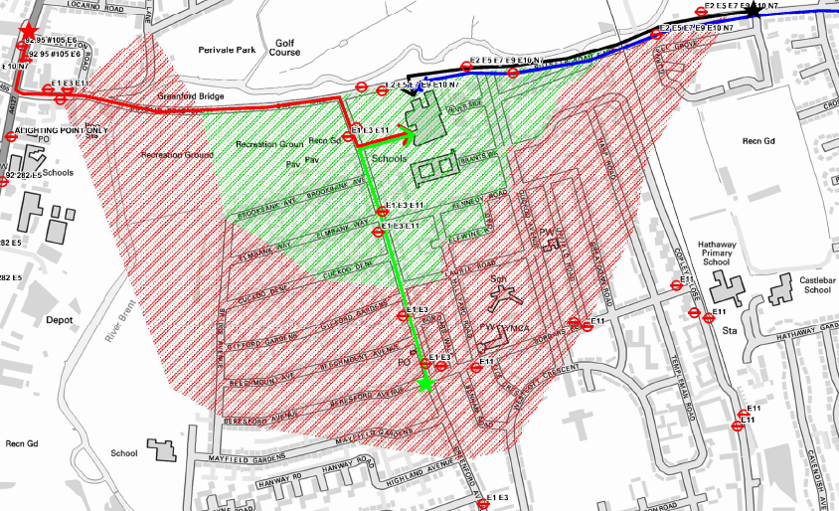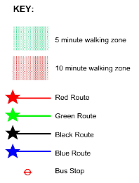
BIKERS REWARD CARD
Another great way to generate enthusiasm about your campaign. The prize could be cycling accessories or a trip your nearest cycle park e.g. Olympic VeloPark, Hillingdon Cycle Circuit, Redbridge Cycling Centre.

AIM:
- Increase the numbers of students cycling to school by providing an incentive.

TOP TIPS FOR USING A BIKERS REWARD CARD:

- YTAs stamp reward cards at the bike sheds. This is easiest to do in the morning as students arrive. You could create a cycle monitors rota to take it in turns to stamp the cards.
- Students with three or more stamps will be entered into a prize draw at the end of the week for a chance to win a prize.
- YTAs count the number of bikes before, during and after the competition, in order to measure the impact of the campaign.

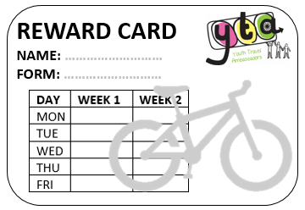

BIKERS BREAKFASTS OPTION
- Students who cycle to school are rewarded with a FREE breakfast.
- Find out what students would like and arrange a time and space with your school canteen.
- Popular menus include croissants, brioche, Babybel, Frubes, Fruit Juice and a selection of fresh fruit. This will cost around £30 depending on how many students you anticipate taking part.

BIKEABILITY OPTION
- You can get FREE cycle training from your Borough Council. This is great for increasing your safety and confidence for cycling to school.
- Ask your Borough Officer for more information.

EXTRA IDEA: RAP, POETRY OR SONG COMPETITION
This is a great initiative to raise awareness of the benefits of active travel and to get everyone talking about your campaign!

- Launch a competition to create a rap, poem or song to motivate students to be travel more actively.
- Winning entry performed in assembly.

Here is an example by Joshua Sweeny:

Kids be free,
Kids be fit,
We know you’re chomping at the bit,
Get off the sofa and get outdoors,
If you do so there’ll be rewards,

Ride a bike or even run a race!
Walk from school at your own pace,
What’s in it for me, I hear you say?!
The chance to get fit and seize the day,
Ditch the Xbox and join the YTA,
Together we can make a change

The Invisible Gorilla by Christopher Chabris and Daniel Simons:

Walking is the first thing an infant wants to do and the last thing an old person wants to give up. Walking is the exercise that does not need a gym. It is the prescription without medicine, the weight control without a diet, and the cosmetic that can’t be found in a chemist. It is the tranquilliser without a pill, the therapy without a psychoanalyst, and the holiday that does not cost a penny. What’s more, it does not pollute, consumes few natural resources and is highly efficient. Walking is convenient, it needs no special equipment, is self-regulating and inherently safe. Walking is as natural as breathing.

