SCHOOL LOGO
YOUR SCHOOL NAME HERE
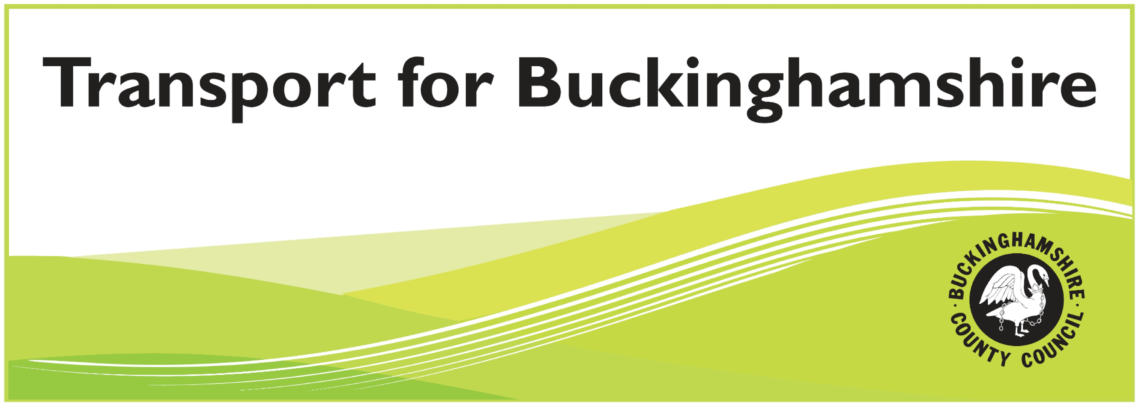

Welcome to NAME OF YOUR SCHOOL. Buckinghamshire County Council in conjunction with the name of your team has produced this information leaflet to encourage students and parents to think about their journey to school making it safer and more sustainable. The students have worked very hard to produce some fun quizzes and guidance to help you to plan a safe journey to school in September which we hope you will find useful. We wish you every success in your new school.

Transport Strategy Team
Transport ⋅ Economy ⋅ Environment, Buckinghamshire County Council
Welcome letter from your Travel Plan team

For your own article/quiz/etc – here are a few questions to start with – answers on the back page

1 Name 5 countries that drive on the left?

2 What is the minimum daily bus fare for a child to travel from add the name of a location near your school to a destination that many students will travel to, ie town, cinema?

3 What is the minimum daily bus fare for an adult to travel from as above?

Walking is healthy, reduces congestion outside the school and is great for the environment. Why not plan how you would walk to the school over the summer holidays? Practice the route to see how long it takes and work out where the safest places are to cross roads.

Below are the main walking routes that most students use; you could even meet up with your friends on the way.

Walking directions to name of your school

Add main walking routes/map with basic directions for example:-

Main start point, junction, roads that you walk along, general turn left, turn right directions, giving safe crossing points etc.

You could include information about wearing hi-vis clothing to keep them safe, not crossing roads whilst listening to their mp3 players or texting.

Try and walk it’s not that hard once you get used to it and it’s good for the environment.

Did you know that a brisk one mile walk takes around half an hour and can burn up to 150 calories!
If you can – Walk!
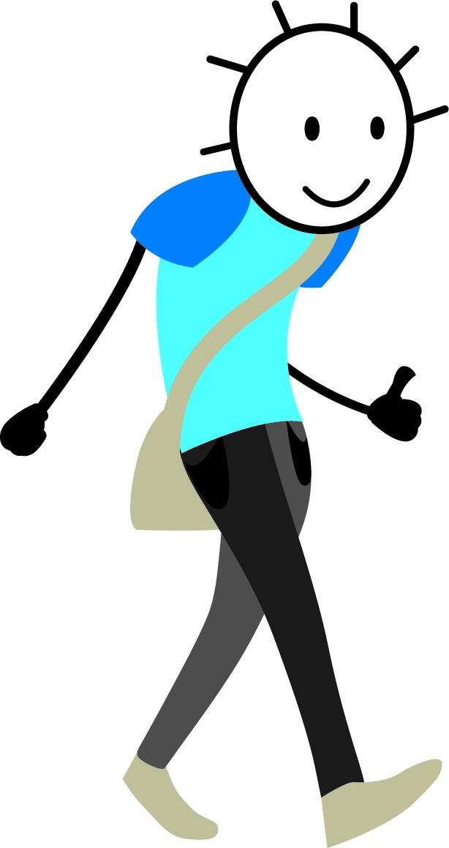
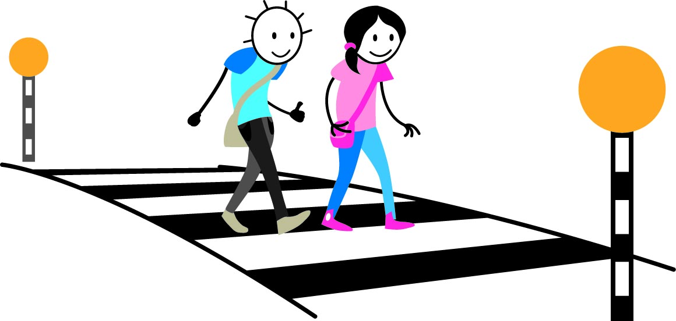
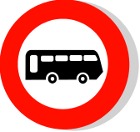
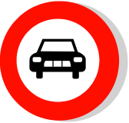

Most students who travel by bus use either the PUT IN THE MAIN ROUTES OR GIVE INFORMATION ABOUT THE HOME TO SCHOOL TRANSPORT PROVISION

When travelling by public transport or school bus students should:

- wait sensibly for the coach or train and board in an orderly manner
- remain seated throughout the journey
- always wear a seat belt on a coach/bus
- avoid distracting the driver, particularly by throwing items and shouting
- respond immediately to any safety instructions issued by the driver
- treat drivers and all passengers with courtesy and respect

To establish whether there is a suitable bus route that you can use please visit www.travelinesoutheast.org.uk
This site is easy to use and helps you plan journeys using public transport.

If you do have to travel to the school by car, please try to share your journey with other students to reduce the number of cars travelling to our school. You could also park and walk – park a little further from the school to prevent congestion and walk some of the way in with your friends. When the car drives it burns fuel and emits fumes that contain the gas carbon dioxide (CO2). Added together with CO2 from other cars it has a major effect on the amount of CO2 in the atmosphere and contributes towards global warming.

Insert details of any voluntary one way schemes that you run or where you would prefer parents to park. Maps can be put on the back page

Travelling by bus?
Have to come by car?

HOW MUCH DO YOU KNOW ABOUT ROAD SAFETY?
Feel free to add your own questions or more suitable ones

1 Where is the safest place to cross the road at school?

2 What does this sign mean?


3 What are the main stages of the Green Cross Code?

4 Why is it dangerous to wear headphones when walking?

5 On traffic lights—which colour means get ready to go?

Travel Plan quiz
Answers

1Anguilla, Antigua & Barbuda, Australia, Bahamas, Bangladesh, Barbados, Bermuda, Bhutan, Bophuthatswana, Botswana British Virgin Islands, Brunei, Cayman Islands, Channel Islands, Ciskei, Cyprus, Dominica, Falkland Islands, Fiji, Grenada, Guyana, Hong Kong, India, Indonesia, Ireland, Jamaica, Japan, Kenya, Lesotho, Macau, Malawi, Malaysia, Malta, Mauritius, Montserrat, Mozambique, Namibia, Nepal, New Zealand, Pakistan, Papua New Guinea, St. Vincent & Grenadines, Seychelles, Sikkim, Singapore, Solomon Islands, Somalia, South Africa, Sri Lanka, St Kitts & Nevis, St. Helena, St. Lucia, Surinam, Swaziland, Tanzania, Thailand, Tonga, Trinidad & Tobago, Uganda, United Kingdom, US Virgin Islands, Venda, Zambia, Zimbabwe
2£ find out the fare
3£ find out the fare
Space for voluntary one way systems/preferred parking maps

How much do you know about road safety?
Answers

1 At the central reservation
2 No through road (dead end)
3 Stop, look, listen
4 You can’t hear what is going on around you, ie traffic, people approaching you from behind
5 Amber

