Parents Parking Promise Campaign

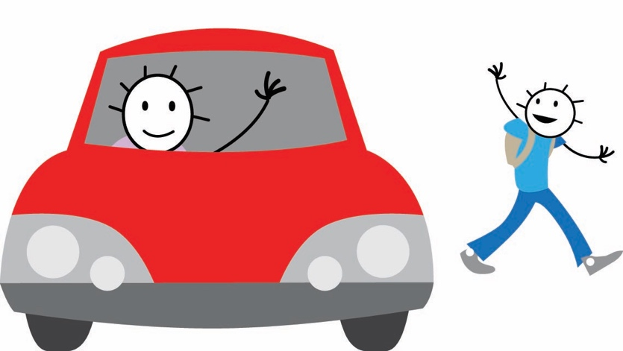

Guidelines

Updated by the School Travel Planning Team June 2018

PARENTS PARKING PROMISE GUIDELINES

- Background

Parents’ Parking Promise was developed to encourage parents and guardians to think about how they are parking around the school and to sign a pledge to promise to park responsibly. The initiative works well in schools where there are particular problems with parents and guardians parking inconsiderately and dangerously.

2. How does the initiative work?

Parents are asked to sign a ‘promise’ to say that they will park responsibly around the school. The promise is returned to the school (usually someone in the school office) who will issue the parent a car sticker to show they have signed the promise. The sticker acts as a reminder to the parents that they should be parking responsibly near the school and as a reminder to others to do the same.

3. What do we provide?

We can provide the schools with the following:
- A sample Parents’ Parking Promise document.
This document can be adapted to suit the specific needs of the school, for example it could include road names or locations, and it could also include further information on related issues that the school would like to resolve.
- Car stickers for parents or guardians who have signed the promise.
These stickers should be displayed in the windscreens of those that have signed the promise in order to highlight to others that they have agreed to park considerately.

4. Contact us

To find out more about Parents’ Parking Promise please contact:
schooltravelplanning@buckinghamshire.gov.uk

