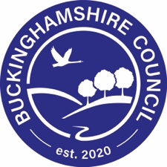
Road Safety Lesson Plans

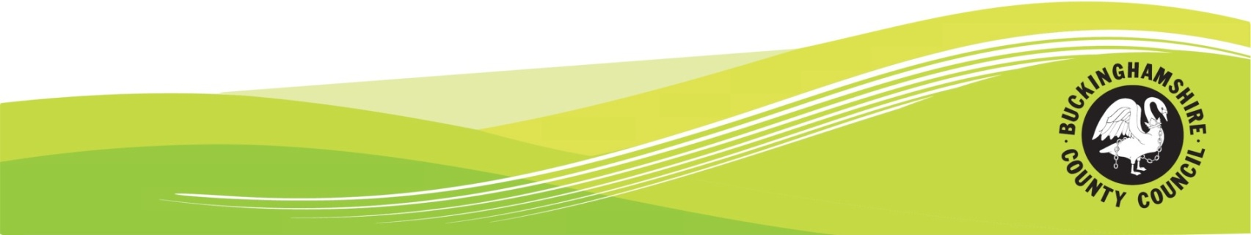
Road Safety Lesson Plans

This pack is designed to help any interested party promote road safety in schools. Please note that you do not have to follow this pack, you may already have lesson plans or ideas on teaching road safety to children.

Level 1 – Suitable for Infant Schools

Introduction
In this section you should introduce yourself to the children and talk about what you are going to do today. You could include the following information:
- Your name
- What your job is
- That you are here to talk about road safety and help them learn how to stay safe on the roads.

Lesson:

You may like to do some of the following activities with the children you are talking to. Please feel free to adapt any activities and suggestions.

You may like to start by explaining why you are here today and why it is important to think about how we act near the road. You could ask the children for their suggestions about why it is important to think about how they are acting near roads. Their probable answers will be:

- To keep us safe
- To make sure we know how to act near the roads
- So we can enjoy our journey to school in a safe way.

Road safety:
You may like to use something similar to the following as a script:
Firstly we are going to think about what we should remember when we are out walking with our parents or guardians.
- Stop
- Look
- Listen
- Think

Traffic:
One of the reasons we need to be careful near roads is the traffic.
What are some of the ways we can tell if traffic is coming? (Answers: we can see it, we can hear it, sometimes we can feel it)

Practical:
You could talk about the traffic and how it is dangerous so we must be careful when we are near the road. Activities you could do with the children include:
- Asking how we can tell the traffic is coming? (Answer: By Stopping, Looking, Listening and Thinking).
Ask when we are listening for traffic what sorts of sounds does the traffic make? The children can join in with the sounds the traffic makes.
- Asking the children if they can think of any parts of your journey to school where traffic is worse than at other places (you may know of local land marks or areas where traffic is worse to prompt them). Tell them we should take special care when around these areas.
- Explain that some traffic moves faster than others so we have to be careful if we can not tell how fast the traffic is moving and that the traffic will be travelling faster than we can. You could show this by doing an experiment.
Experiment: Ask for a volunteer. Roll a ball and ask the child to run next to it. The ball will travel faster than the child. Explain why the ball travels faster (it is round etc). We have to be careful because cars can travel much faster than we can.

Reflective clothing and items:
Explain that you are now going to think about things that might help us stay safe near the road.

Practical: You will need the ability to darken the room. Explain you will only do this for a short amount of time so children are not afraid.
Then make the room dark and shine the torch on the jacket to show that it is reflective.
Questions to ask:
- What is special about the jacket? (expected answers: reflective, bright etc)
- When should we especially think about wearing it? (expected answers: in the dark, near roads, in winter)
- Why is it important to wear something bright? (expected answers: to stay safe, so drivers can see us)

Are there other things that might help us to keep safe near the road or while we are travelling to school?
Probable answers might be:
- Bike Helmets
- Seatbelts

You may like to explain why it is important to wear a seatbelt or bike helmet.

Explain that there are a lot of things to think about when being near a road and that they have made a really good start today with thinking about some of these things.

Reiterate what you have learned:
For example, today we’ve talked about some of the things we need to think about when we are near the road.

Always remember to stop, look, listen and think before crossing the road.

Traffic can be fast and dangerous so we should always take care near the road.

We can help keep ourselves safe by wearing reflective or bright clothes, wearing bike helmets when we cycle and wearing seatbelts in the car

Questions - Are there any questions you would like to ask me?

Things to take: Tabard, torch, ball, or toy car.

Level 2 – Suitable for Junior Schools

Introduction
In this section you should introduce yourself to the children and talk about what you are going to do today. You could include the following information:
- Your name
- What your job is
- That you are here to talk about road safety and help them learn how to stay safe on the roads.

Lesson:

You may like to do some of these activities with the group of children you are talking to. Please feel free to adapt any activities or suggestions.

Road Safety:

Signs
We’re going to talk about one of the ways in which we know how to act near or on the road – signs.

Practical: We are going to talk about different signs you might see when you are out and what they mean.

Start by asking if anyone can think of any shapes of road signs?
Most popular answers are ‘circle’ or ‘triangle’.

Circular signs give orders
- Blue Circles usually tell you what you must do or show that a particular type of traffic will be using that route. Hold up the example blue sign. Can you think of any examples of blue signs? Once you have given the pupils a chance to think about any examples, hold up some of the given examples.
- Red circles usually tell you something you must not do. Can you think of any examples? Once you have given the pupils a chance to think about any examples, hold up some of the given examples.

Triangular signs usually give warnings.
- Can you think of any triangular signs? Hold up the example of the red triangular sign. Once you have given the pupils a chance to think about any examples, hold up some of the given examples.

Rectangular signs give information.
- Can you think of any examples of information that might be given on a sign? Once pupils have given answers give them some examples

Who might help you?
There are people that might help you get to school safely. We are going to talk about some of these people and how they might help you. We are going to do an activity to try and match up people that help and what they might do to help us.
Practical: matching statement to people. Ask which people each statement might refer to (it may be to more than one person)

You could talk to the children about what you do as PCSO – ie, make sure nobody is parked inconsiderately, making sure parents aren’t talking on their mobile phones, trying to make it safe for everybody.

Reiterate what you have learned:

We have learned that there are ways of knowing how to act on the road, for example, signs can tell us what to do and what not to do.

There are people who help us with road safety.

Questions – Are there any questions you would like to ask me?

Things to take: Examples of signs, list of statements and examples of people.

Level 3 – Suitable for Key Stage 3

Introduction
In this section you should introduce yourself to the children and talk about what you are going to do today. You could include the following information:
- Your name
- What your job is
- That you are here is talk about road safety and that it is important to consider road safety even at an older age.

Lesson:

You may like to consider some of the following with the group of pupils you are talking to. Please feel free to adapt any activities or suggestions.

Practical: Firstly you could discuss how road safety aware they think they are. This could be followed up with a rate yourself activity.
Ask them to rate themselves against the statements – how good or bad they are at these things?
1 is very good, 2 is good, 3 is average, 4 is bad and 5 is very bad.
- I always wait until the green man is shown on a pelican crossing before I cross.
- I never text on my phone when I am near or crossing a road.
- I never listen to my ipod or wear headphones when near the road.
- I never joke around with or push my friends when near a road.
- I always look both ways before crossing the road.
- I never mess around when I am on a bus.
- I always wear a helmet when I ride a bike.
- I always wear bright clothes when I am out in the dark.

Ask them to add up their scores to see how road safety aware they are. The lower the score the more road safety aware they are.

Distractions: In this section you could talk about the types of distractions they may face. This could be mobile phones, headphones, music, their friends etc.

Peer pressure:
Talk about what would be an assertive way to deal with different situations. Situations you could discuss include:
- Your friends are messing around near the round and you are worried that they may cause an accident.
- People are messing around on the school bus and you think they may cause an accident.
- None of your friends are wearing a cycle helmet. You would like to wear one but you are worried that they will make fun of you.

How would you deal with each one in an assertive (but not aggressive) way – you may have to explain the difference between passive, assertive and aggressive.

Reiterate what you have learned:

We have thought about how we act around roads and if we are aware of the dangers there are near traffic.

We have talked about some distractions near roads and about peer pressure. We have talked about what makes and assertive person.

Questions – Does anyone have any questions?

Key Stage 4 may like to make up their own lesson plan.

Contact us

For more information about School Travel Planning, please visit the website
www.schooltravelplanning.com

Information taken from DfT Lesson plans, Brake Road Safety Website, Road Safety Week website.

