**no entry sign**

**Some examples:**

**no right turn no access trailer**

**no U turn no horses sign**

**no HGV**

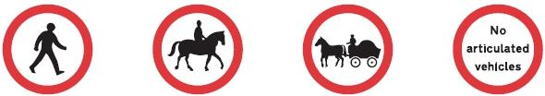

**no cars**

**give a way**

**Some examples:**

**sharp turn rightnarrow rightsharp turns right and leftwarning drop**

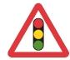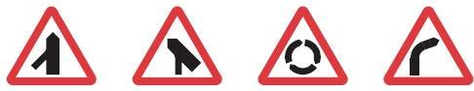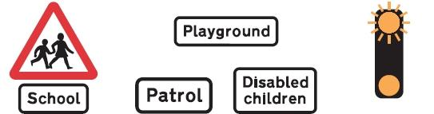

**Some examples:**

