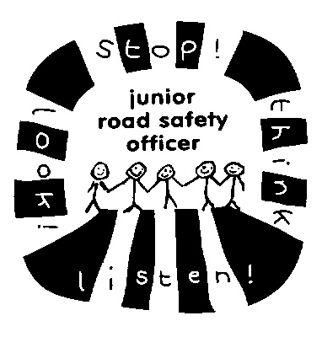

Hello, did you know how dangerous parking on yellow lines and pavements outside our school can be?
The more cars that park around the school, the more likely it is that one of us, or possibly YOUR child will be hurt, so would you mind moving to a space away from our school that is safer please?

Hello, did you know how dangerous parking on yellow lines and pavements outside our school can be?
The more cars that park around the school, the more likely it is that one of us, or possibly YOUR child will be hurt, so would you mind moving to a space away from our school that is safer please?

