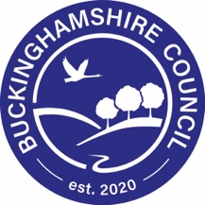

**Walking newsletter articles**

Some schools include articles in their school newsletter to inform parents of School Travel plan initiatives or for reminder about driving and parking sensible near schools. These newsletter articles are deigned for you to be able to copy and paste into your school newsletters. Please feel free to amend any articles as appropriate for your school.

You will notice some sentences or words are highlighted in yellow. These are phrases or words which you will need to adapt for your school.

**Go for Gold**

**Go for Gold**

XXX School are starting a new initiative which will help get children active on the journey to school and help reduce congestion around the school. Go for Gold is a scheme which encourages pupils to walk, cycle, scoot, park and walk or use other forms of sustainable travel to school. Each time a child comes to school/ to and from school they will gain a tick in their Go for Gold passport. The passports will be given to your child by XXX. XXX will be ticking passports in the morning. Once your child has completed a passport you can exchange this for one of a number of free activities including swimming, golf and bowling! (A letter showing participating centres will be given out and accompanies the completed passport to gain a free reward). The scheme will be starting on XXX. We hope to see lots of you walking, cycling or scooting to school!

**Walk to School Week and Walk to School Month**

**Walk to School Week**

XXX-XXX May is national Walk to School Week and we are going to be supporting this week. National Walk to School Week encourages as many people to walk to school as possible, helping to get children active on the journey to school and also helping to reduce congestion around the school gates. The theme for this year’s Walk to School Week is XXX and children will be given a sticker for their efforts. We hope to see lots of you walking to school.

**Walk to School Month**

October is national Walk to School Month and we are going to be supporting this week. National Walk to School Month encourages as many people to walk to school as possible, helping to get children active on the journey to school and also helping to reduce congestion around the school gates. The theme for this year’s Walk to School Month is XXX and children will be given a sticker for their efforts. We hope to see lots of you walking to school.

Images you may like to use:

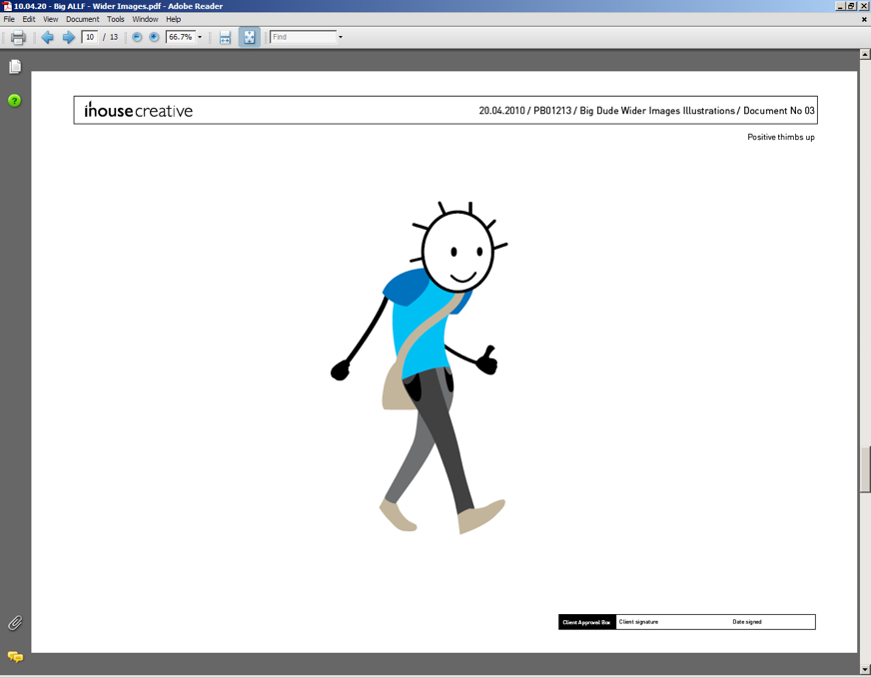

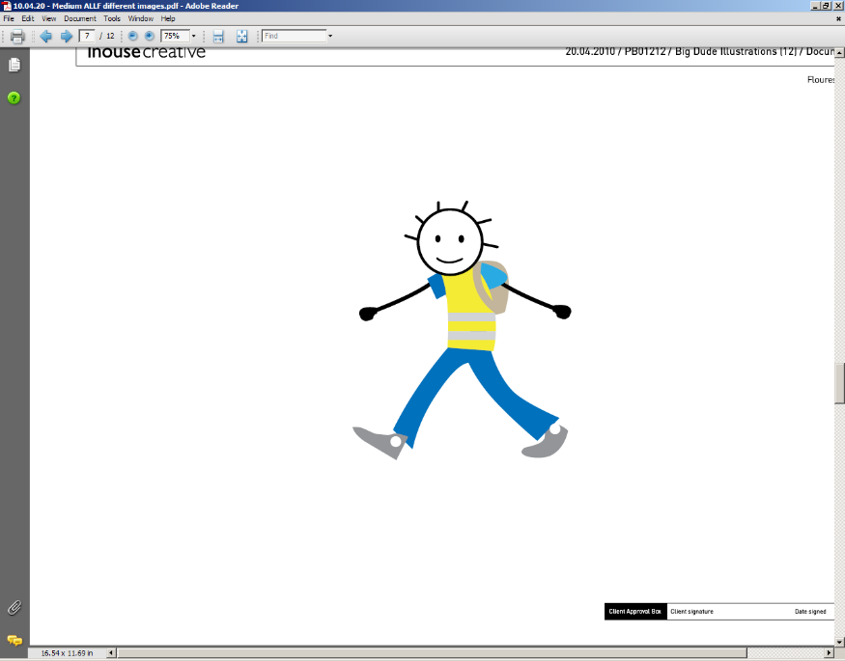

**Footsteps**

**Introducing Footsteps training**

Footsteps is a pedestrian skills programme which aims to give children practical road safety skills. The training is aimed at Key Stage 1 and covers safe places to cross the road, stop, look and listen, fast and slow traffic and the Green Cross Code amongst other aspects of basic road safety. We will be carrying out training with Year XXX this term.

**Footsteps training - volunteers**

Footsteps is a pedestrian skills programme which aims to give children practical road safety skills. The training covers safe places to cross the road, stop, look and listen, fast and slow traffic and the Green Cross Code amongst other aspects of basic road safety. We are looking for volunteers who would be willing to help teach the pupils these valuable lessons. Training to become a Footsteps tutor is given by Transport for Buckinghamshire’s Travel Planning team and then the Footsteps training with pupils is carried out near school. The training will take a morning and then XXX time to train the pupils.

Images you may like to use:



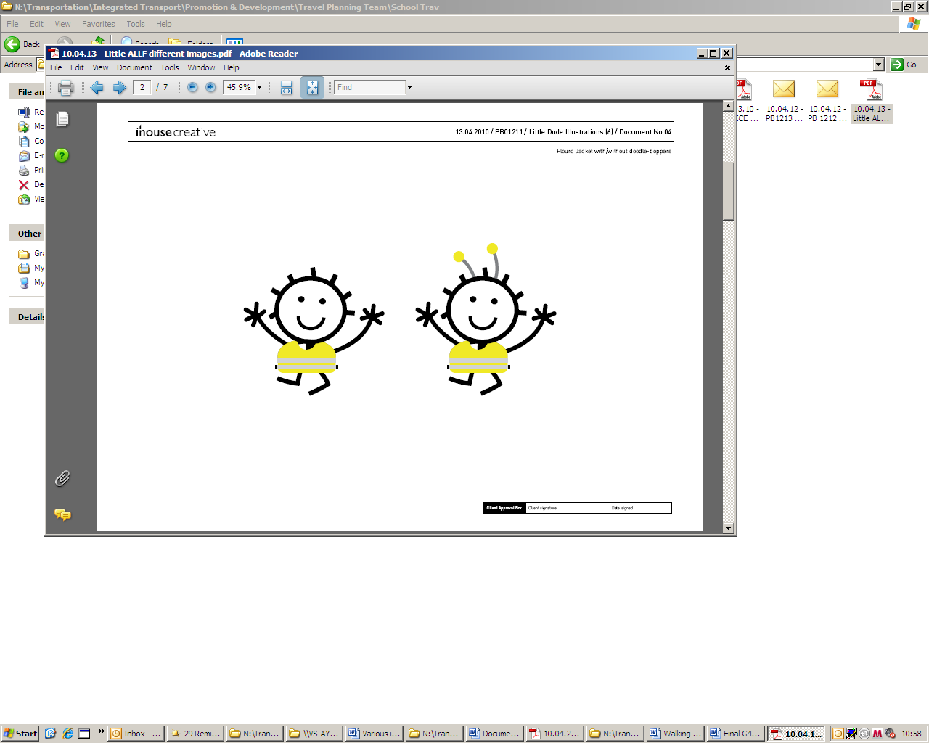

**Crocodile**

**Crocodile**

A crocodile is Buckinghamshire’s version of a walking bus and we are hoping to start running a route to school. Children walk along a route to school, which will be risk assessed. The pupils are escorted by volunteers and wear high visibility clothing. We are looking for volunteers who would be able to help as an escort on the route. We are hoping to run the route from XXX. If you are able to volunteer to be an escort on the crocodile route please see XXX. Thank you.

Images you may like to use:

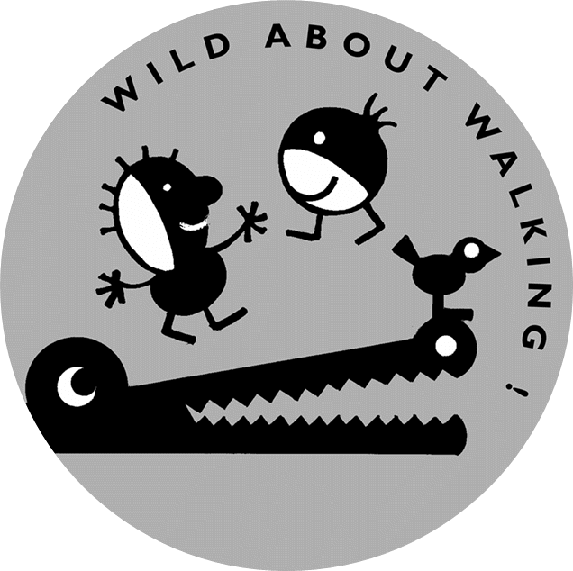

**Park and Walk**

**Park and Walk**

At XXX we have been thinking about how we travel to school and making sure we keep the area outside the school free from congestion. This will not only help keep the relationship with our neighbours but will also make it safer for our pupils to cross the roads near the school. We are therefore promoting a new park and walk site. A park and walk site is an area in which you can park and walk the remainder of the way to school. Our suggested park and walk site is XXX. We have had permission form the owners of the car park that parents can park here for the school start and finish times. We hope you will take the opportunity to use the park and walk site to help ease the congestion around school in the mornings. Thank you.

Images you may like to use:

