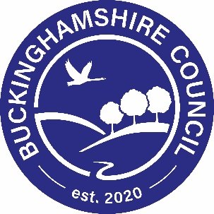

JRSO Annual and Fun Day Registration

School Year 2020/21
School:
Number of JRSOs:
Helpers Details
Contact details for monthly bulletins and correspondence
Name:
Email address:
Details of any other people who would like to receive bulletins
Name |  |  |  |  | Email
JRSO Fun Day Registration
Coach House, Green Park Centre, Aston Clinton (new venue)
Date: postponed until October 2021
Number of Children (Max 4):
Helper Name |  |  |  |  |  | Email
Please tick your preferred choice of session to attend (unable to guarantee this) |  |  |  | AM: |  |  |  | PM:

Please return this page to: Emma.James@buckinghamshire.gov.uk

