We also have images you can use on your social media channels and newsletters to support considerate parking:

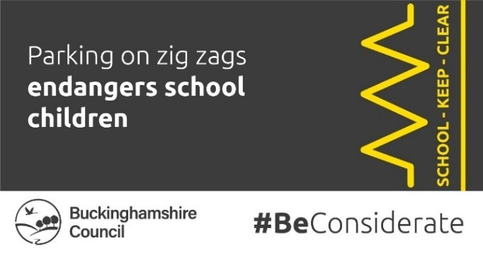 | 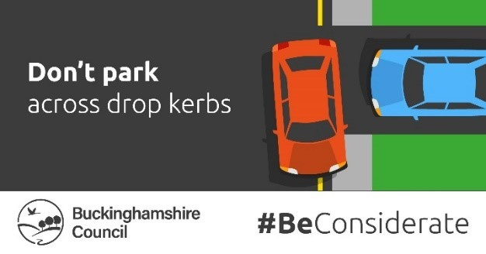
Image demonstrating that parking on zig zags endangers school children. | Image requesting people not to park across drop kerbs.
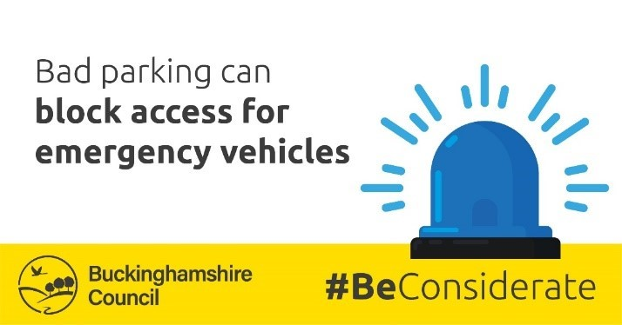 | 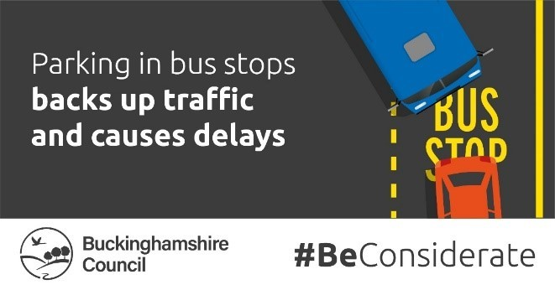
Image demonstrating that bad parking can block access for emergency vehicles. | Image demonstrating that parking in bus stops backs up traffic and causes delays.
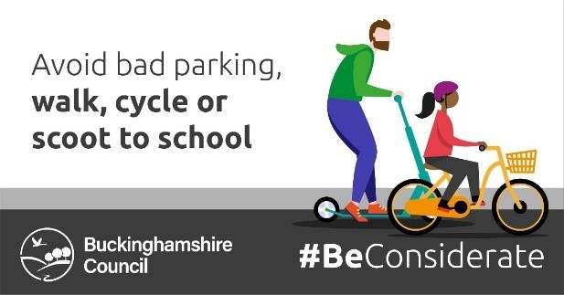 | 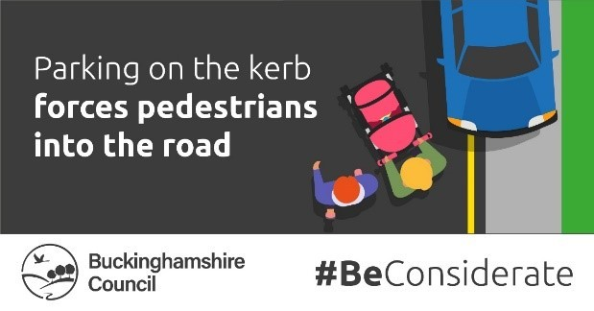
Image suggesting avoiding bad parking, walk, cycle or scoot to school instead | Image demonstrating that parking on the kerb forces pedestrians into the road.

